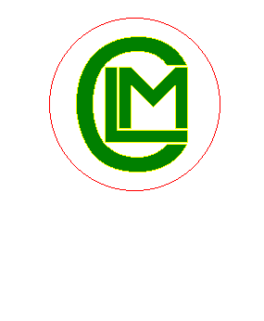
Community Land Management Inc.

PO Box 90,

Renmark S.A. 5341
e-mail : CLM@communitylandmanagement.org.au

CLM Malleefowl Nest Surveying DEWNR 2014/15

January 2015.

CLM members surveyed Malleefowl Grids in Danggali Conservation Park & Chowilla Region Reserve in December 2014...

Four CLM members surveyed the Malleefowl grids volunteering 45 hrs, travelling 580 km in two vehicles while Malleefowl nest surveying in December 2014.

We found Two active Malleefowl nests one in Danggali and one in Chowilla Malleefowl grids.

Grant Geyer
CLM Manager Mallefowl nest surveys…

Grant Geyer BSc(EnvMgt)
Chairperson / Executive
Community Land Management Inc.
PO Box 90,
Renmark SA 5341.
e-m: CLM@communitylandmanagement.org.au
Ph: 0429 694 187.

